Aldehyde Deuteration - Best Model Feature Analysis

Table of Contents

Model Search 1

1st Place 1

Model Analysis - Variable Impact 8

1. NPA_1 Removed 8

2. Dist(2, 7) Removed 15

3. dip_y Removed 22

4. -2-3- Removed 29

### Model Search

### 1st Place

Table:

Full Model Stats - Overall Accuracy and Pseudo-R2

| Accuracy | McFadden_R2 |
| --- | --- |
| 90.48% | 0.577 |

Model Coefficients

|  | x |
| --- | --- |
| -2-3- | -0.3801322 |
| dip_y | -1.5680528 |
| Dist(2, 7) | 295.8494658 |
| NPA_1 | 47.5647077 |

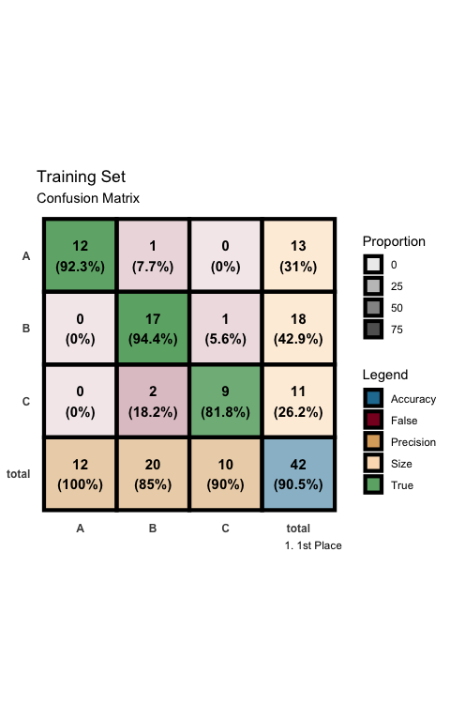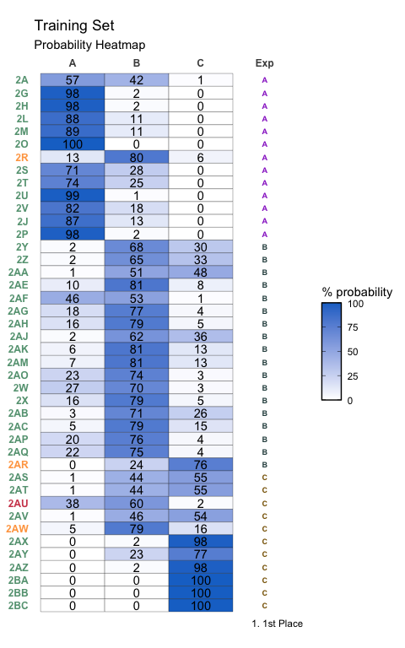

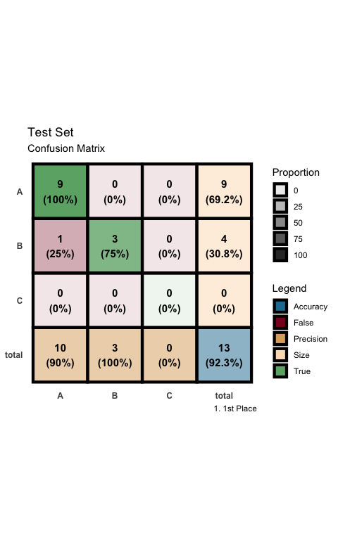

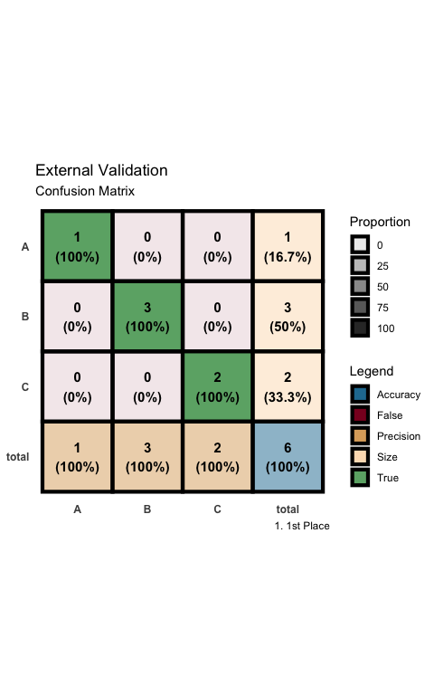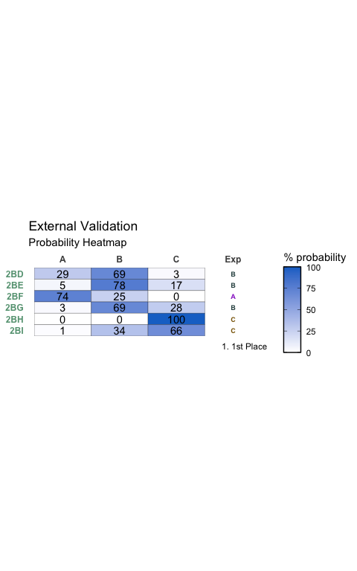

#### New Molecules Prediction

New Molecules - Prediction of Conditions

|  | Predicted | 1 | 2 | 3 |
| --- | --- | --- | --- | --- |
| 2BJ | 3 | 0 | 0 | 100 |
| 2BK | 1 | 73 | 27 | 0 |
| 2BL | 2 | 29 | 69 | 3 |
| 2BM | 1 | 100 | 0 | 0 |
| 2BN | 3 | 0 | 0 | 100 |
| 2BO | 3 | 0 | 0 | 100 |
| 2BP | 1 | 100 | 0 | 0 |
| 2BQ | 1 | 100 | 0 | 0 |
| 2BR | 1 | 100 | 0 | 0 |
| 2BS | 1 | 100 | 0 | 0 |
| 2BT | 1 | 100 | 0 | 0 |
| 2BU | 1 | 57 | 42 | 1 |
| 2BV | 2 | 25 | 72 | 3 |
| 2BW | 2 | 1 | 58 | 41 |

## Model Analysis - Variable Impact

### 1. NPA_1 Removed

| formula |
| --- |
| class ~ -2-3- + dip_y + Dist(2, 7) |

Full Model Stats - Overall Accuracy and Pseudo-R2

| Accuracy | McFadden_R2 |
| --- | --- |
| 71.43% | 0.338 |

Model Coefficients

|  | x |
| --- | --- |
| -2-3- | -0.1882832 |
| dip_y | -0.9381293 |
| Dist(2, 7) | 145.2808583 |

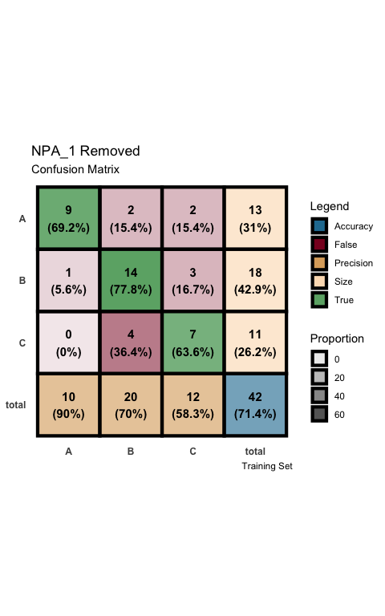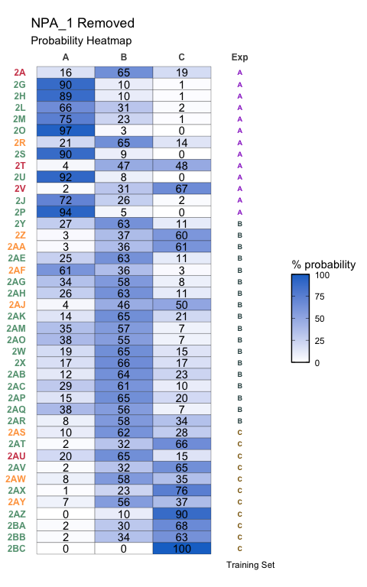

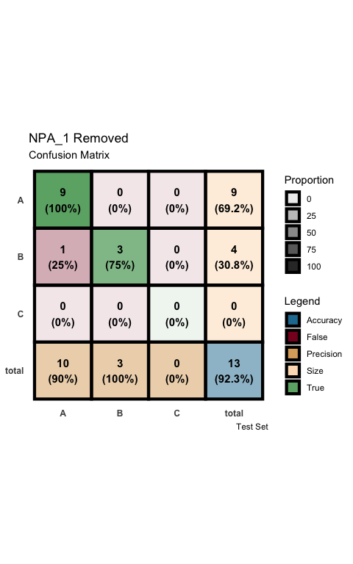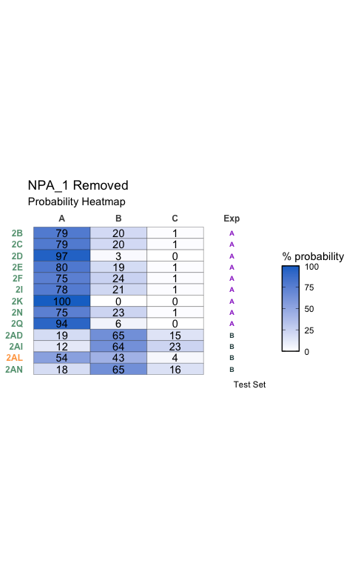

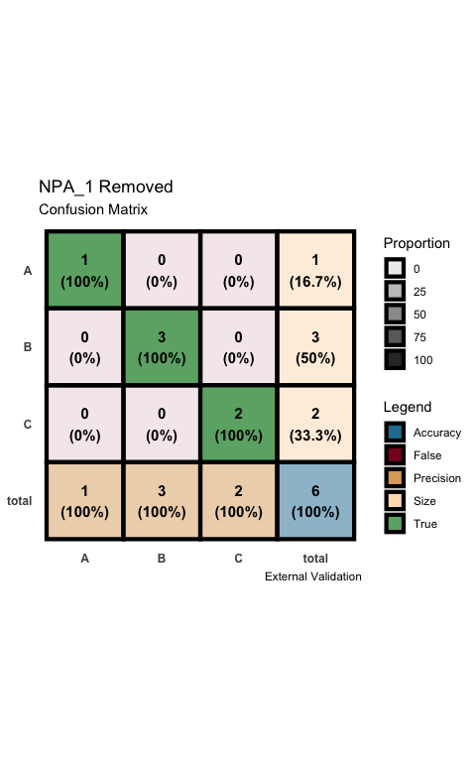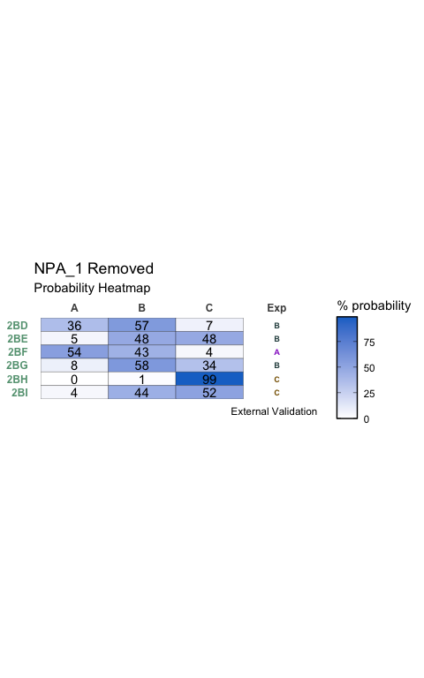

### 2. Dist(2, 7) Removed

| formula |
| --- |
| class ~ -2-3- + dip_y + NPA_1 |

Full Model Stats - Overall Accuracy and Pseudo-R2

| Accuracy | McFadden_R2 |
| --- | --- |
| 78.57% | 0.452 |

Model Coefficients

|  | x |
| --- | --- |
| -2-3- | -0.076705 |
| dip_y | -1.830226 |
| NPA_1 | 27.040639 |

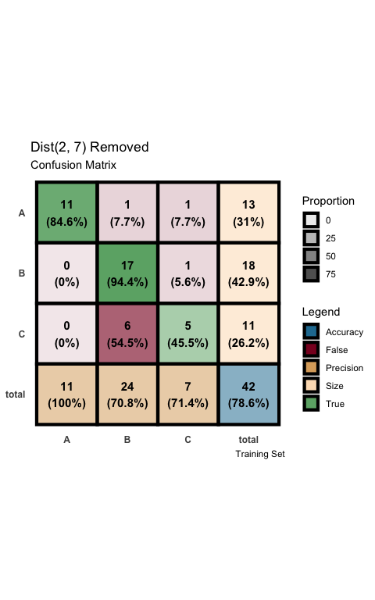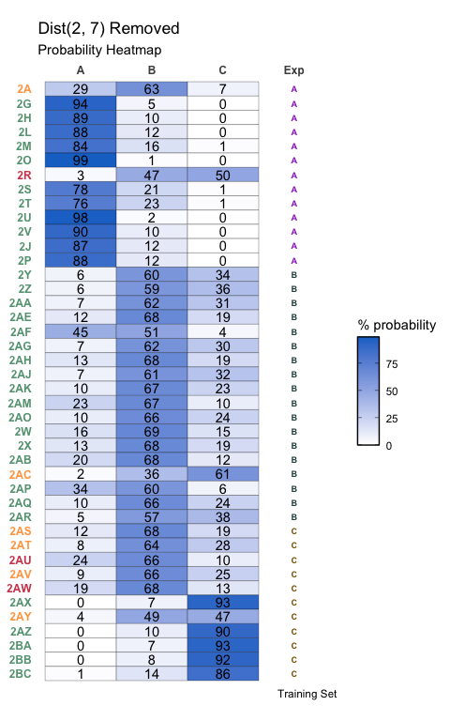

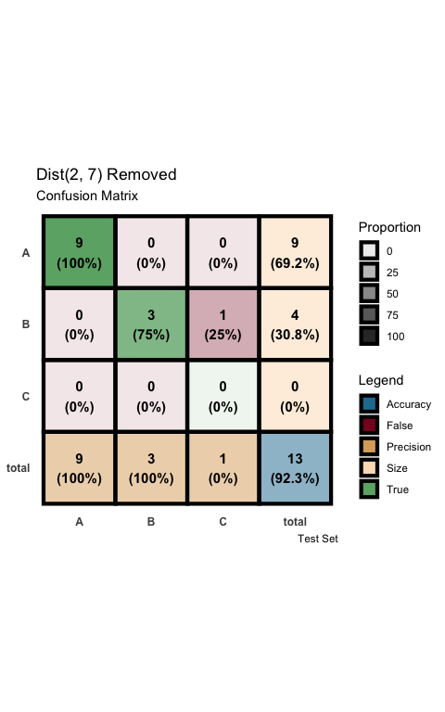

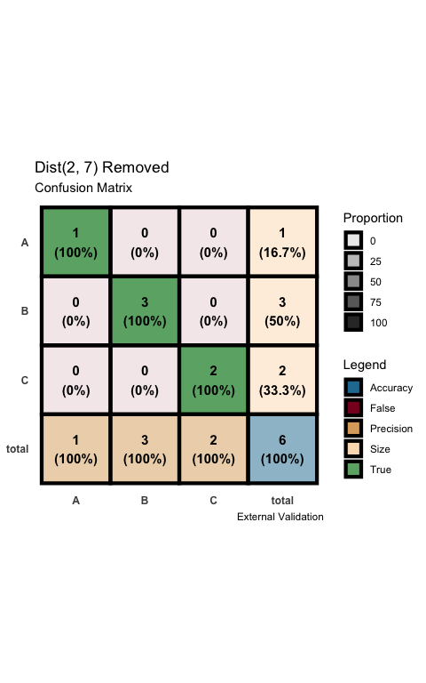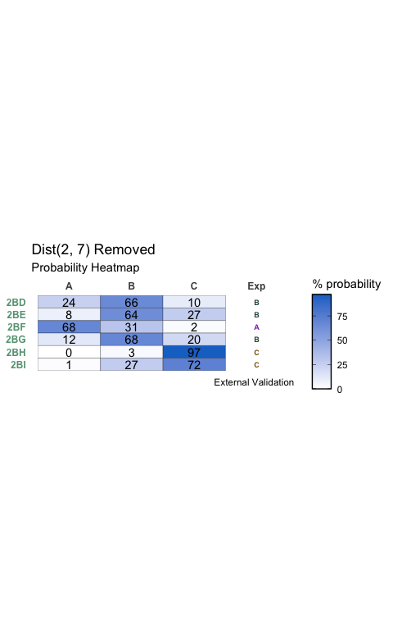

### 3. dip_y Removed

| formula |
| --- |
| class ~ -2-3- + Dist(2, 7) + NPA_1 |

Full Model Stats - Overall Accuracy and Pseudo-R2

| Accuracy | McFadden_R2 |
| --- | --- |
| 69.05% | 0.217 |

Model Coefficients

|  | x |
| --- | --- |
| -2-3- | -0.0879166 |
| Dist(2, 7) | 73.6506465 |
| NPA_1 | 15.3035790 |

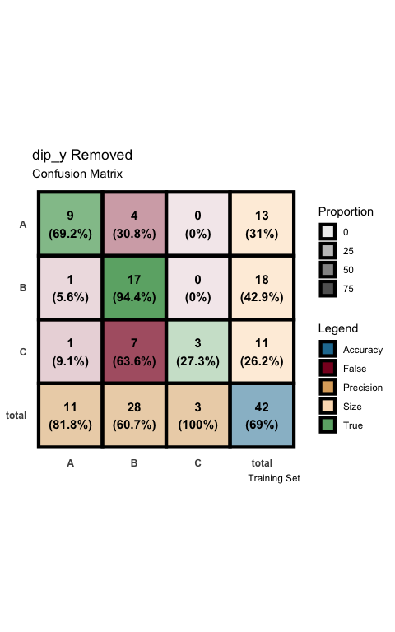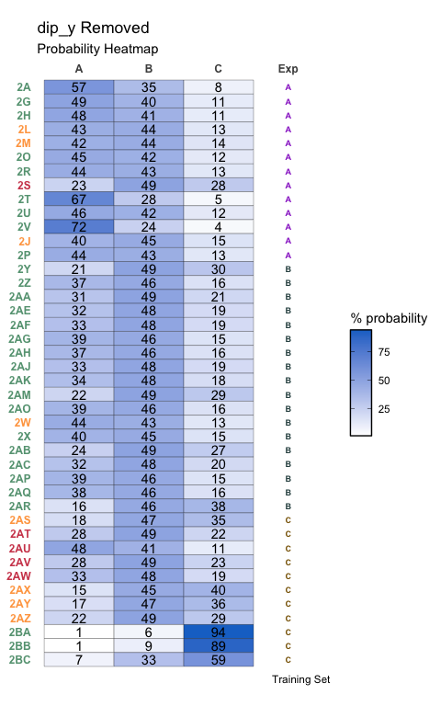

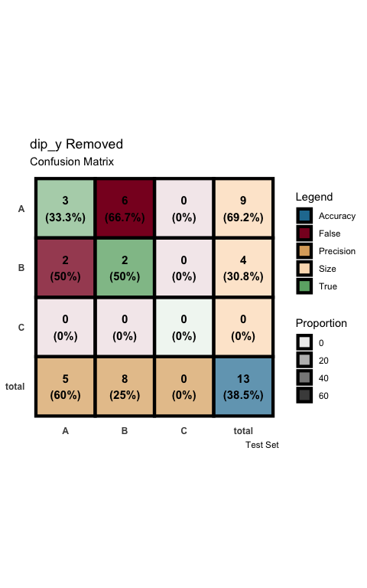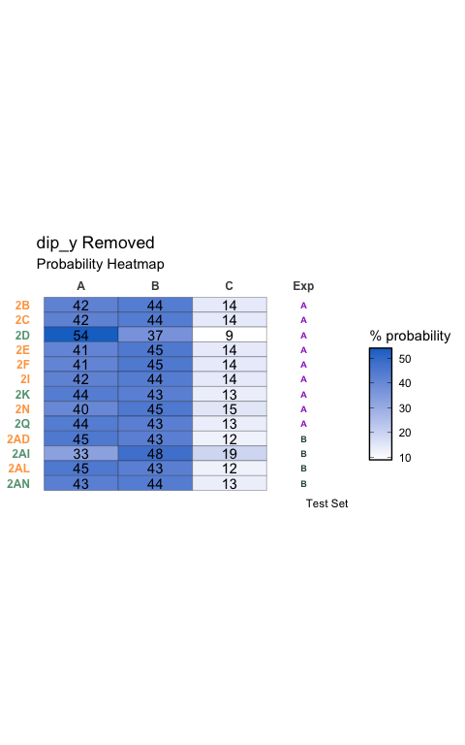

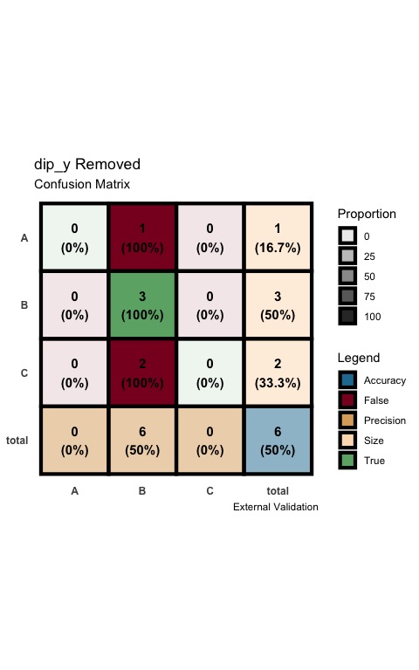

### 4. -2-3- Removed

| formula |
| --- |
| class ~ dip_y + Dist(2, 7) + NPA_1 |

Full Model Stats - Overall Accuracy and Pseudo-R2

| Accuracy | McFadden_R2 |
| --- | --- |
| 76.19% | 0.344 |

Model Coefficients

|  | x |
| --- | --- |
| dip_y | -1.932190 |
| Dist(2, 7) | -7.774941 |
| NPA_1 | 23.524905 |

